**Colour the circle in the right colour!**

|  |  |  |  |  |  |
| --- | --- | --- | --- | --- | --- |
|  | White |  | Pink |  | Grey |
|  | Yellow |  | Purple |  | Brown |
|  | Orange |  | Blue |  | Black |
|  | Red |  | Green |  |  |

Favourite colour

What is your favourite colour?

My favourite colour is _______________.

Colour by number

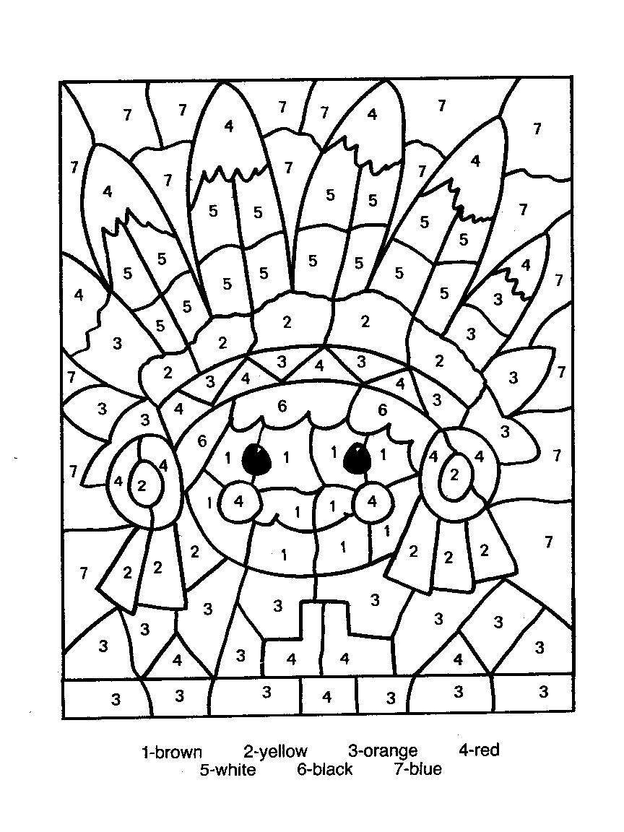

1= brown

2= yellow

3= orange

4= red

5= white

6= black

7= blue

**Saludos**

**Look at the pictures. Read.**

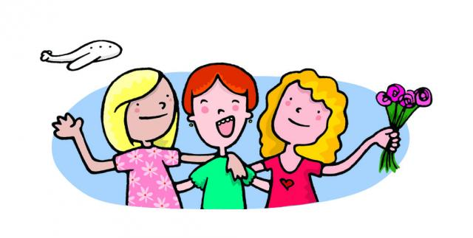 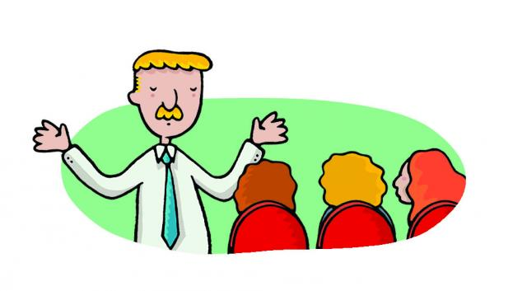

**- Hello, Martine! -Good afternoon, everybody! Sorry for the delay**

**- Hi, Liz! Today we …**

**- Welcome to Buenos Aires.**

**- Thank you! I’m happy to be here**

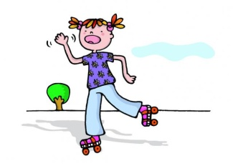

**-Bye-bye, aunt Annie! See you soon!**

**-Bye, Sophie, take care!**

**-Good luck!**

**1) Match the expressions**

1. Hello, I’m Sophie. Thank you.
2. Good-bye! Nice to meet you, too.
3. Good afternoon. Hi, I’m Tom.
4. Nice to meet you. Good afternoon.
5. Welcome to our school. See you tomorrow

**2**) Match with the time.

Good afternoon 6 am - 11:50 am

Good evening 12 pm - 6 pm

Good morning 6 pm - 11:50 pm

**Hello / How are you today / What’s your name**

**Good aftenoon / Good bye/ and you /Good morning**

**3) Complete the dialogue**

Teacher : Good morning class!

Sts: ……………………………….. Miss Susie!

Teacher: ……………………………………………………….?

Sts: Fine, ………………………..?

T: Very well thanks.